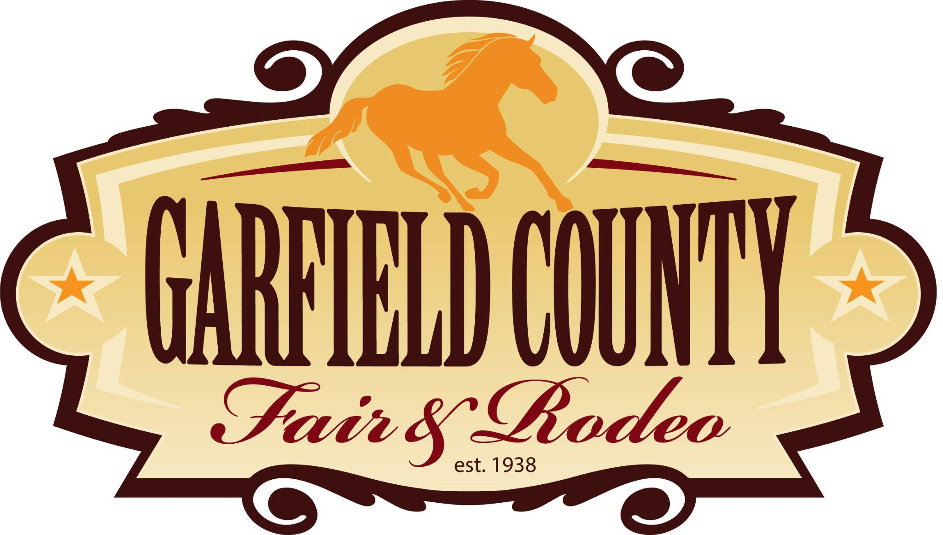

**GARFIELD COUNTY FAIR BOARD AGENDA**

**Garfield County Administration Building**

108 8th St

Glenwood Springs, CO 81601

**Tuesday, May 13, 2025**

**6:00 P.M.**

Join Zoom Meeting

<https://zoom.us/j/95912607859?pwd=NUCGGCIBWzhvjkD0askPOG0Z1beapE.1>

Meeting ID: 959 1260 7859

Passcode: 749823

**Mission:**

The purpose of the Fair Board is, in collaboration with Garfield County Administration, to ensure the successful promotion, production, and execution of the Fair each year.

The Fair Board shall ensure Fair programming is of high quality and that programming improves

annually, as needed.

Fair programming:

* Shall embrace all ages, persons, cultures, and entities within Garfield County
* Shall foster a spirit of community values
* Shall promote the Western and agricultural heritage and history of Garfield County.

**ROLL CALL - 6:00 P.M.**

**PLEDGE OF ALLEGIANCE**

**PUBLIC COMMENTS FROM CITIZENS NOT ON THE AGENDA** **– 6:05 p.m.**

Individuals may be limited to 5 minutes each.

**APPROVAL OF MINUTES FOR THE APRIL 1st REGULAR MEETING:**

**REPORTS:**

1. **Fair Partners, Programs & Committees**
   1. Royalty
   2. 4-H/FFA/CSU Extension
   3. Livestock Marketing Committee
   4. Rifle Chamber
   5. City of Rifle
2. **Mountain Valley Developmental Services – Maura Masters**
3. **Fair Board Bylaws Section 10 – Fair Board Member Removal - Heather Beattie**
4. **Open Exhibits** 
   1. **Live on Website… Any updates?**
   2. **Social Media post on Facebook 5/5/25**
5. **Sponsorship**
   1. **Deadline for Ad space is MAY 30th**
   2. **Review sponsorships and delegate calling businesses from 2024 who have not signed up for 2025**
   3. **In kind sponsors need to fill out sponsorship application – who is missing?**
   4. **Outstanding invoices… can they still sponsor?**
   5. **Comedy Show Sponsors or Non-Profits?**
6. **Hall of Fame**
   1. **Who**
   2. **Notification**
7. **Family Rodeo**
   1. **Is this happening?**
8. **Fair book**
   1. **DEADLINE MAY 30th -Communications needs min of one week to finalize & vendor needs 4 weeks to print- If we stay on schedule ETA July 7th**
   2. **Missing items:**
      1. **Royalty Photos & Article**
      2. **Hall of Fame Article**
      3. **In Memoriam (2)**
      4. **Message from President**
      5. **Family Rodeo?**
      6. **Thank you, 2024 Livestock show buyers**
      7. **FFA Profiles**
9. **Kick Off Events Updates**
   1. **Sponsorship BBQ**
      1. **Rib City Confirmed**
10. **Special Events Updates**
    1. **Car Show Updates**
       1. **The Mixx Band Confirmed 12pm-3pm**
    2. **Skillet Toss**
       1. **Is this happening? If so, when?**
11. **Safety/ Security Updates**
12. **Midway Updates**
    1. **Entertainment**
       1. **Comedy Show Confirmed**
       2. **Tractor Pull Confirmed**
       3. **Cowboy Cove Confirmed**
       4. **Freckle Farm Petting Zoo & Pony Rides**
    2. **Vendors**
    3. **Free Stage**
       1. **Hanna Haupt (Wednesday 5-7) Confirmed**
       2. **Band called Alexis (Thursday 9-11) Confirmed**
       3. **Tyler Rust Band (Friday 9-11) Confirmed**
       4. **Stone Kitchen (Saturday 9-11) Confirmed**
       5. **Line Dancing Instruction (Thursday 5-6:30pm; Friday 12-1:30pm) Confirmed**
13. **Volunteer Updates**
14. **VIP Updates**
    1. **Linens resolution?**
    2. **Meals**
       1. **Brickhouse Confirmed for Wednesday?**
       2. **Jalisco’s Confirmed for Thursday?**
       3. **Friday?**
       4. **Rib City Confirmed for Saturday**
15. **County Staff**
    1. **County Administration**
    2. **Fairgrounds and Events Manager**

**BOARD COMMENTS:**

**ADJOURNMENT:**